Task I: What I’ve done was, I created a new folder under the workspace folder where I named it: ArchOSC Assignment. Inside this said folder I added 3 documents, them being: A folder called: Pictures where I would store all the screenshot that I will be taken during the lab and a Word document called: Lab 2 Placeholder. Took a screenshot of both folders and saved it in “pictures”. (This process will be done at every task/step during the whole lab)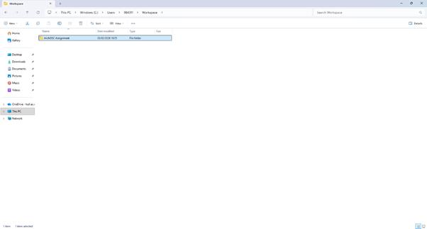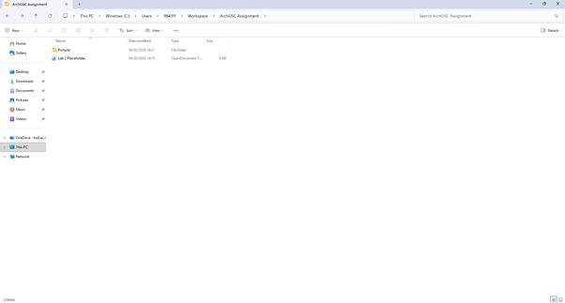

Task II: I opened the terminal and input the command “git init” to create a local repository. After I have had created the git within the folder, I repeated the process of taking a screenshot and saving into the “Pictures” folder.

Task III: Went into GitHub and created an online repository. Pressed the “new” button that led me to a tab where I could choose certain setting to create my repository correctly. Set myself as the owner, added “README”, set the repository name to: ARCHOSC-Assignment-RicardoSebastiao, the visibility was put “private” and on the section “add gitignore” I selected: Visual Studio. After all that I pressed enter and therefore, created my repository.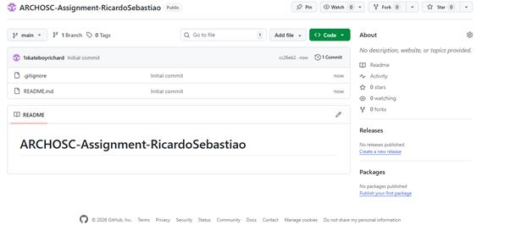

Task IV:

